AVC Modelling and Design

AIM
When considering the design for the robot we took into the consideration the dynamics of the movement of the robot given its purpose. At first we overlooked the challenge ahead and the restrictions placed upon us. The robot has to move correctly in accordance with the semi-free flowing line with the correct dynamics. In the second part the robot has to act and move with a measured estimate of 6 inches of space. These are amoungst only a few things that were considered when designing the chassy.

Modeling
The initial measurements were taken (the records can be found on the GitHub; note: these measurements were only initial and does not include everything, only what was nessecary for the CAD design) and through colaboration a few designs were drafted. After eliminating designs through a trial and error process, we found that the design as shown below would best meet the criteria. Showing a economic and efficent model, re-useable, functional (taking into the consideration the placement of the external parts of the pi), and most importantly minimises the amount of space the robot takes up.
The diagram to the right shows the top part of the presumed final design. The concept was that the top would lock into the bottom and hold the pi inbetween, as seen on the right.
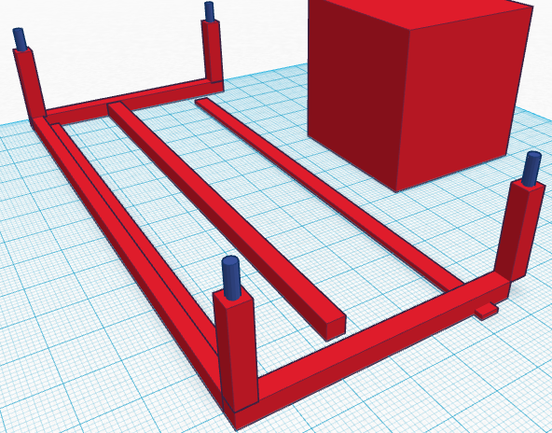
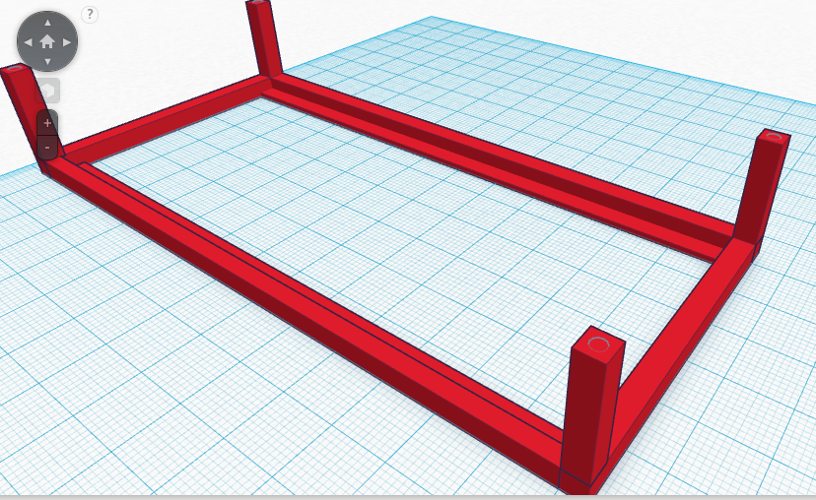
`For our purpose this was perfect, however another problem arose. The width and length of the robot might cause issues when it came to the turning radius in the maze. After being shown a few alternatives to our design we redrafted a design with the pi sitting horizontal to the surface. The pi itself and the extension board would be held in between two or three “plates” which would be held together by the plastic screws provided.
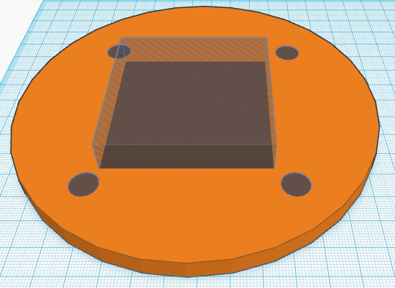
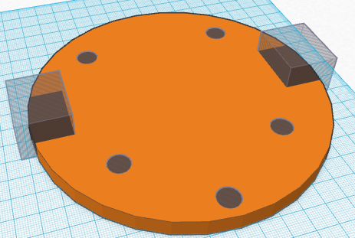
This design can be seen on the right (thre grey or blank shapes are spaces that are hollow and ae placed stategically for the screws and based off the measurements of the pi and its extension board. Once again once we over looked the re-useability and the function. Instead of using excess materials, we in turn decided wed use the part that have been given to us. Relying soley on the base board to be attached to the pi and keep it in place. After consulting the in lab technitians the disposiable materials we would be using were suitable to be used. So after a few hours of trial and eror the following changes were made and a final model was produced.
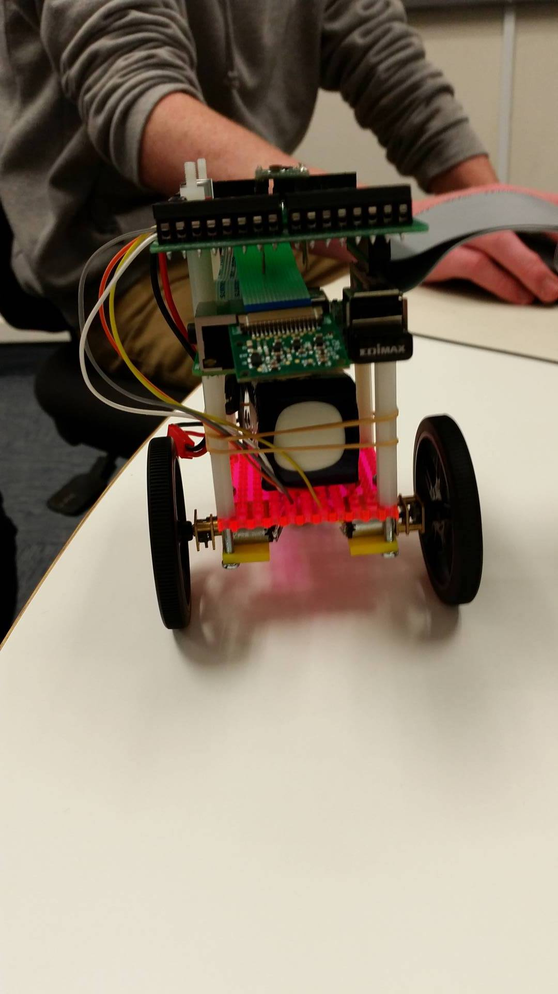
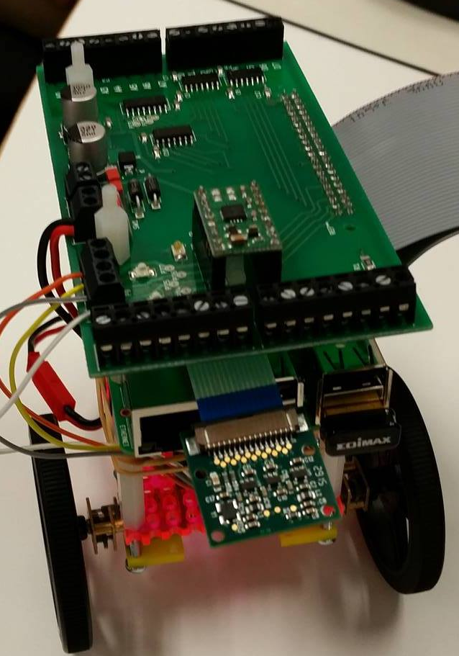
- adjusted the orientation of the pi and extension board.
- the placement of the wheels in relation to the weight and height
- The orientations and placement of the camera to maximise efficency
- position and consideration of sensors

To the right you can see a near completion model in the pictures below. Left to be done is the camera arm (yet to be 3D printed) and the back wheel almost complete.

`

